Cleobury Food Bank

Annual Report

2022

History, Aims and Objectives

Cleobury Food Bank was established in October 2019 to relieve food poverty and financial hardship in Cleobury Mortimer and the surrounding area.

It is a collaborative project managed by the Town Council, St. Mary’s Church and St. Elizabeth’s Church. There is a steering group with representatives of all three organisations.

The finances of the Food bank are managed by the Town Council Finance Officer.

The Food Bank was established when it became apparent that individuals and families in need in Cleobury Mortimer and the surrounding area were having to travel to other towns such as Ludlow, Bridgnorth and Kidderminster to access a Food Bank.

Cleobury Foodbank is a member of the Shropshire Food Bank Network and the Coordinators regularly attend meetings with other food banks.

We achieve our aims and objectives, in particular but not exclusively by:

- The provision of emergency food, items, advice and support to individuals and families in financial need

- Contributing to and co-operating with charities and other organisations

- Giving our users a £5 voucher to be used for the purchase of fresh food (bread/fruit/vegetables/meat/fish) at nominated local shops

Organisation and Governance
Cleobury Food Bank is open on Friday mornings from 9.30 to 11.30 am and continues to operate in the Market Hall in Church Street.
Cleobury Food Bank is managed by 3 Coordinators – Debbie Brown (Town Council Chair), Patrick Buck (Town Councillor) and Beth Gadd (Community Volunteer). Debbie is enhanced DBS checked and is the nominated Safeguarding Lead for the Food Bank.
There is a bank of volunteers who assist at the Food Bank on a rota system. Their duties include:
- Collection of donated goods from the various donation points in the Town
- Checking and marking the donated goods with clear use by dates
- Re-stocking the food storage area
- Distribution of food parcels to Food Bank users
- Offering advice and support to users
- Signposting to other organisations
All volunteers are given both verbal and written advice and guidance about safe lifting, moving and handling and safeguarding adults and children. Volunteers sign up to our Volunteer Charter. The Food Bank has a Safeguarding Policy which is reviewed regularly to ensure inclusion of any statutory guidance.

Achievements and Performance in 2022
When comparing performance from 2020-2022 the Food Bank distributed food as below:
Year | Adult parcels | Child parcels | Total
2020 | 281 | 249 | 530
2021 | 647 | 397 | 1044
2022 | 988 | 620 | 1608

This indicates an increase of Food Bank usage of nearly 60% from 2021 to 2022. Additionally, there were 28 new referrals in 2022.
Many food bank users self-refer, and in 2022 we received referrals from Housing, schools, Social Workers and the Job Centre.

Financial Pressures of 2022
Effects of record inflation: The Independent Food Aid Network reported in February 2023 that 89% of food banks surveyed across the United Kingdom experienced higher demand in 2022, largely due to increases in the cost of living. Inflation hit a 41-year high of 11.1% in October.

According to a House of Lords Library report, the consumer price index, which indicates the inflationary pressures on various goods and services, rose by 9.2% in the 12 months to December 2022. The Office for National Statistics reported that the largest contributing factors to this inflation were rising domestic energy prices and food price inflation.

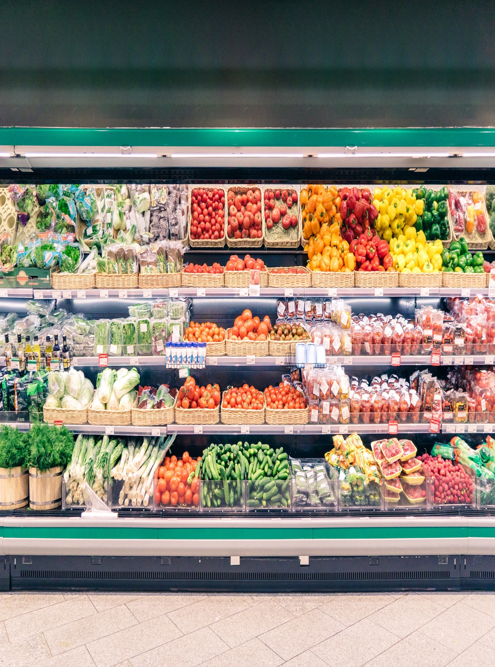

Spiraling food costs: The cost of food and non-alcoholic beverages rose by 16.9% in the 12 months to December 2022, according to the ONS. This was the biggest increase in any of the different components of consumer price inflation, according to the report.
The ONS noted that price increases were particularly steep for some of the lowest-cost household essentials like pasta, tea and bread. The ONS said the food price inflation the UK experienced in 2022 had the harshest effect on the most vulnerable in society, with higher prices having a more detrimental impact on those with lower incomes.

Soaring energy bills: Gas and electricity prices continued to rise rapidly in 2022 compared to the previous year. The ONS reported that almost six in 10 adults were using less fuel in their homes because of rising costs. Electricity prices in the UK rose by 66.7% and gas prices by 129.4% over the course of 2022, according to the ONS.

Even with the energy price cap freeze introduced in October, the average household bill nearly doubled from £1,277 to £2,500 in 2022.
Locally, many households were also hit by higher heating oil costs in 2022. In December 2022, the average price of home heating oil in the UK was approximately 88 pence per litre. This was a year-on-year increase of 38% over 2021.

Low-income members of our community were particularly affected by these increases, as they are more likely to live in homes that aren’t energy efficient.

Benefits not keeping up with inflation: The end of the Universal Credit uplift in October 2021 hit some households in our area quite hard, and it continued to impact their finances well into 2022. Benefits, despite being price-indexed, have not kept pace with inflation over the last few years, and this continues to cause hardship for low-income residents.

Donations

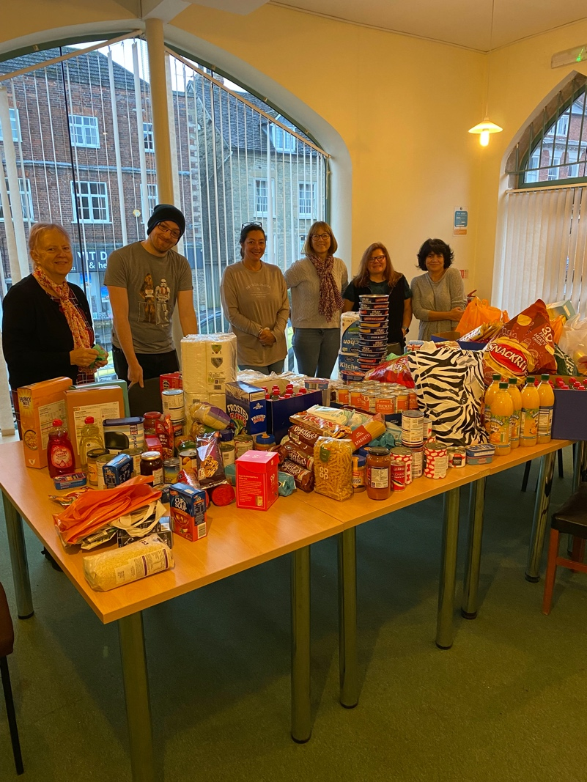

The local community, neighbouring parishes, organisations and Churches have continued to be incredibly generous with donations of both food and cash throughout 2022. The Food Bank has their own dedicated Facebook page and provides regular posts giving information about which items are in short supply. We have a large group of volunteers who are incredibly supportive.
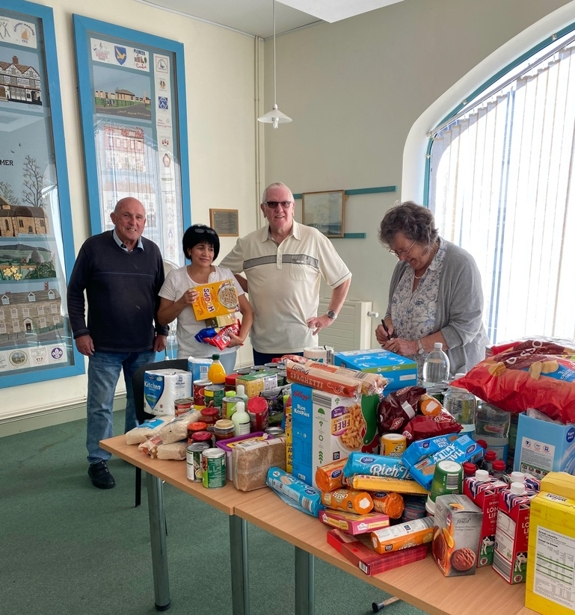

The Food Bank continues to be supported by Mawley Milk with a supply of fresh milk every week for our users, Platters and Plates – who supply fresh baking potatoes, and by Doddington Heights Park who organise a weekly donation collection as a community group, which they deliver to the Hall. In 2021 the Food Bank set up an Amazon wish list for items which has been very successful.

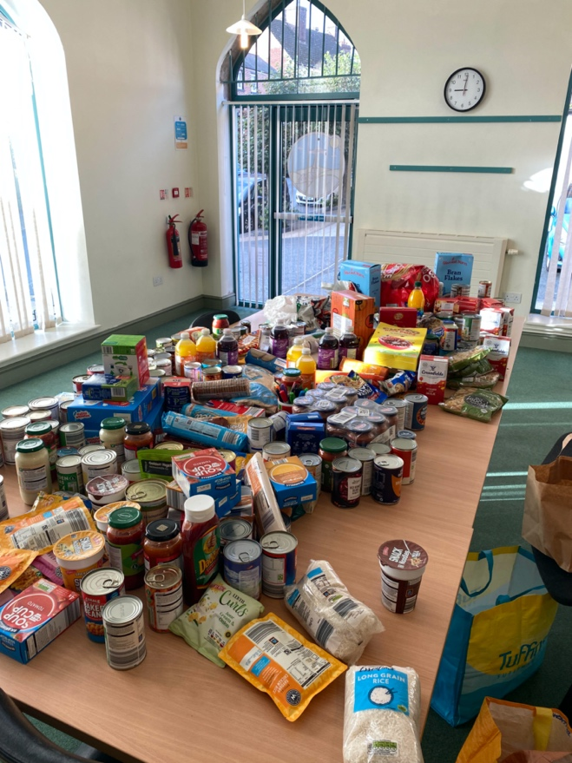

The Food Bank also receives regular cash donations and a small number of standing orders from members of the local community, and in 2022 we were gifted a large cash donation by an anonymous donor.

In addition to the food parcels given out, every family/single person attending the Food Bank is also given a £5 food voucher. These are only redeemable at local shops (The Coop, Ashley’s Bakers, Cleobury Freezer Centre, Londis and Select and Save) to enable the purchase of fresh food (meat/fish/baked goods/fruit and vegetables, etc)

Christmas Hampers
In 2022 we were again able to provide a Christmas hamper to all of the families/individuals that attend the Food Bank, and following a donation from a local group we were able to supply 12 families with a slow cooker and to give every child a toy shop gift card.

Networking
The Food Bank continues a collaborative approach to tackling food poverty and financial hardship by networking with other organisations - local housing officers, local schools, Shropshire Warm Homes Initiative and CAP (Christians Against Poverty) as examples.
A Food Bank coordinator also attends the local strengthening families meeting along with Children’s Services, Youth workers, the Police and local Schools.

Looking to the future
Cleobury Food Bank will be looking to become a charitable organisation in 2023. This will enable us to apply for other grant funding not currently available to us.

Financial Statement 1.1.22 - 31.12.2022

Food Bank Income and Expenditure 2022 (currently managed by Cleobury Mortimer Town Council):
INCOME
Standing Order donations | £600.00
PCC Neen Sollars | £395.00
St. Elizabeth’s Church | £240.00
PCC Doddington | £55.20
Crib League | £500.00
Anonymous donation | £10,000.00
Shropshire Masonic SMCA grant | £500.00
Other donations | £530.00
TOTAL | £12,820.20
EXPENDITURE
Room Rental Market Hall | £950.00
Large Room hire Market Hall | £400.00
Redeeming fresh food vouchers | £2,268.00
Petty Cash and running costs | £1,200.00
Sundry items supporting homeless client | £158.98
Toy store gift cards | £300.00
Slow cookers | £59.97
TOTAL | £5,336.95
BALANCE | £7,483.25

